Terraform Task 6

1). Watch the Terraform-06 video.
2). Execute the script shown in the video.
1. Create folder structure
cd C:\Users\padma\Desktop\terraform-task-06
mkdir terraform-module
cd terraform-module
mkdir modules
mkdir modules\ec2 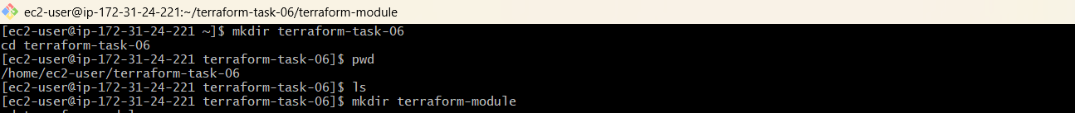
Structure:
terraform-module
│
├── main.tf
│
└── modules
└── ec2
└── main.tf
2. Create child module
modules/ec2/main.tf
resource "aws_instance" "web" {
ami = var.ami
instance_type = var.instance_type
key_name = var.key_name

tags = {
Name = var.name
}
}

variable "ami" {}

variable "instance_type" {}

variable "key_name" {}

variable "name" {}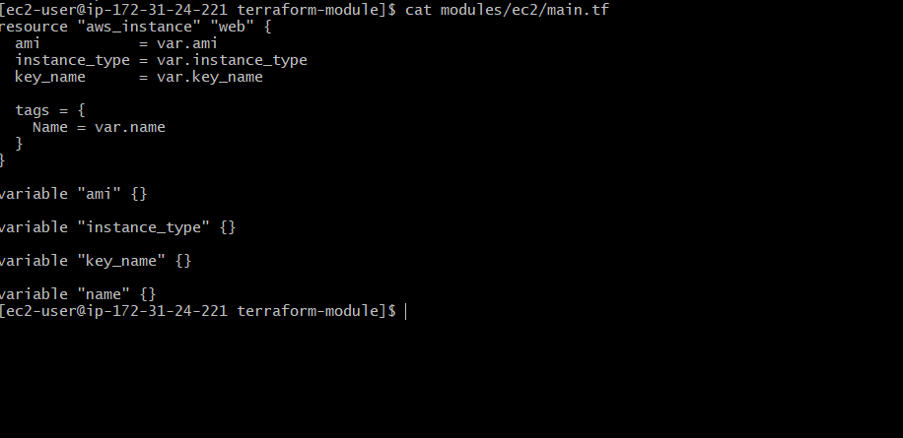
3. Call the module
Root main.tf:
provider "aws" {
region = "us-east-1"
}

module "ec2" {
source = "./modules/ec2"

ami = "ami-0354c98ae10b02961"
instance_type = "t3.micro"
key_name = "krishna7"
name = "module-server"
}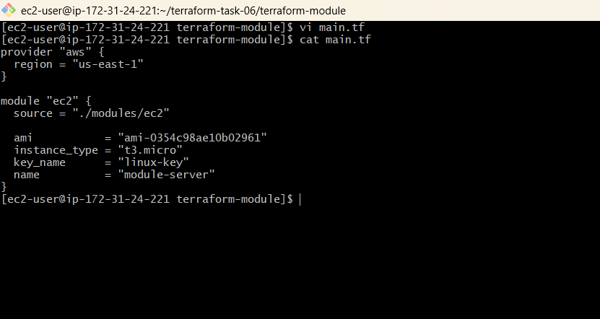

4. Initialize
terraform init 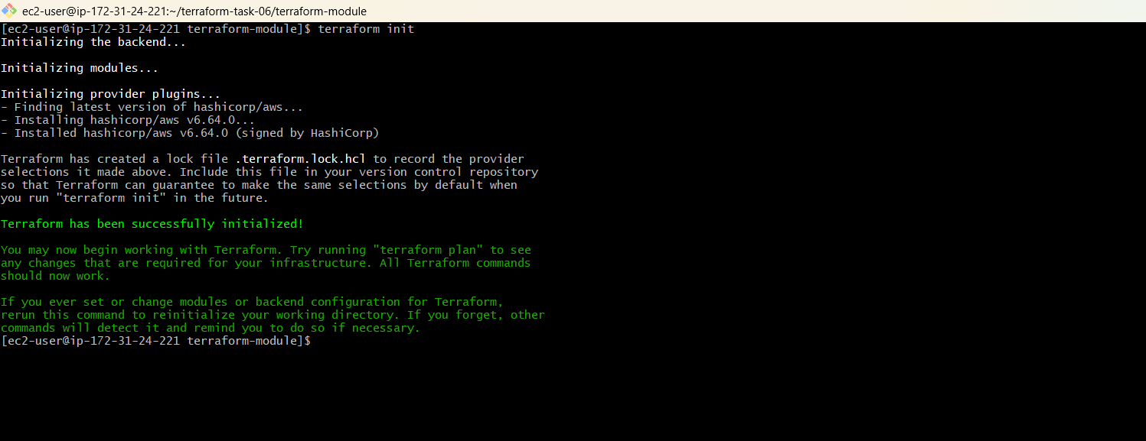
5. Validate
terraform validate
6. Plan
terraform plan
You should see:
module.ec2.aws_instance.web
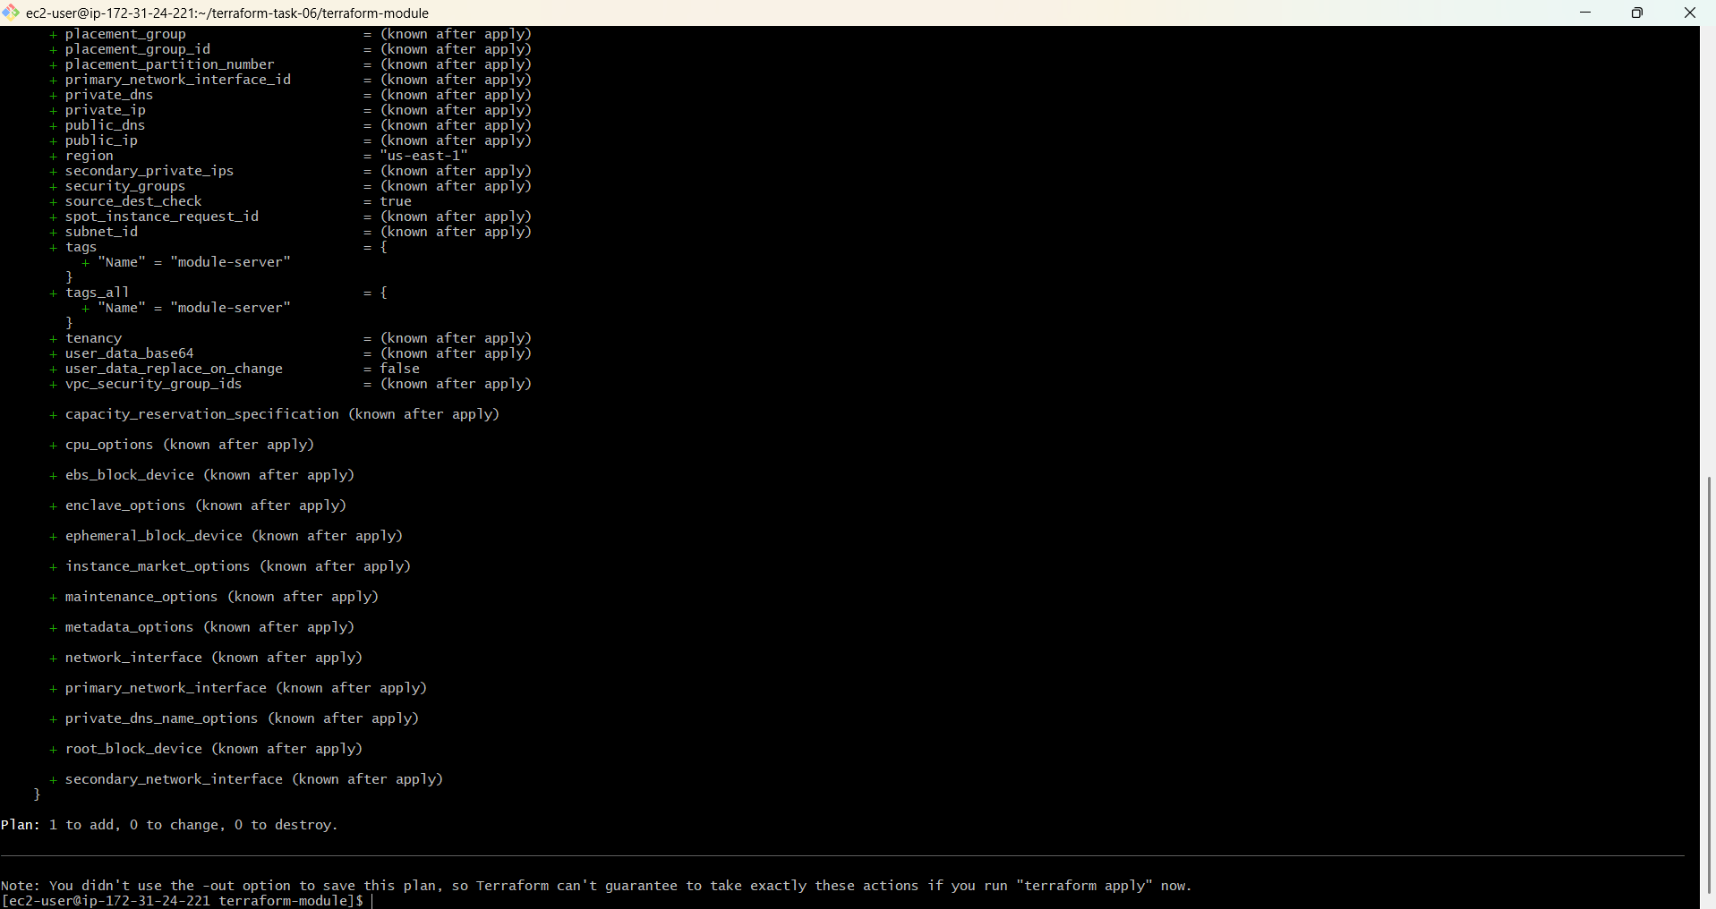

7. Create EC2
terraform apply
Enter:
yes
8. Verify
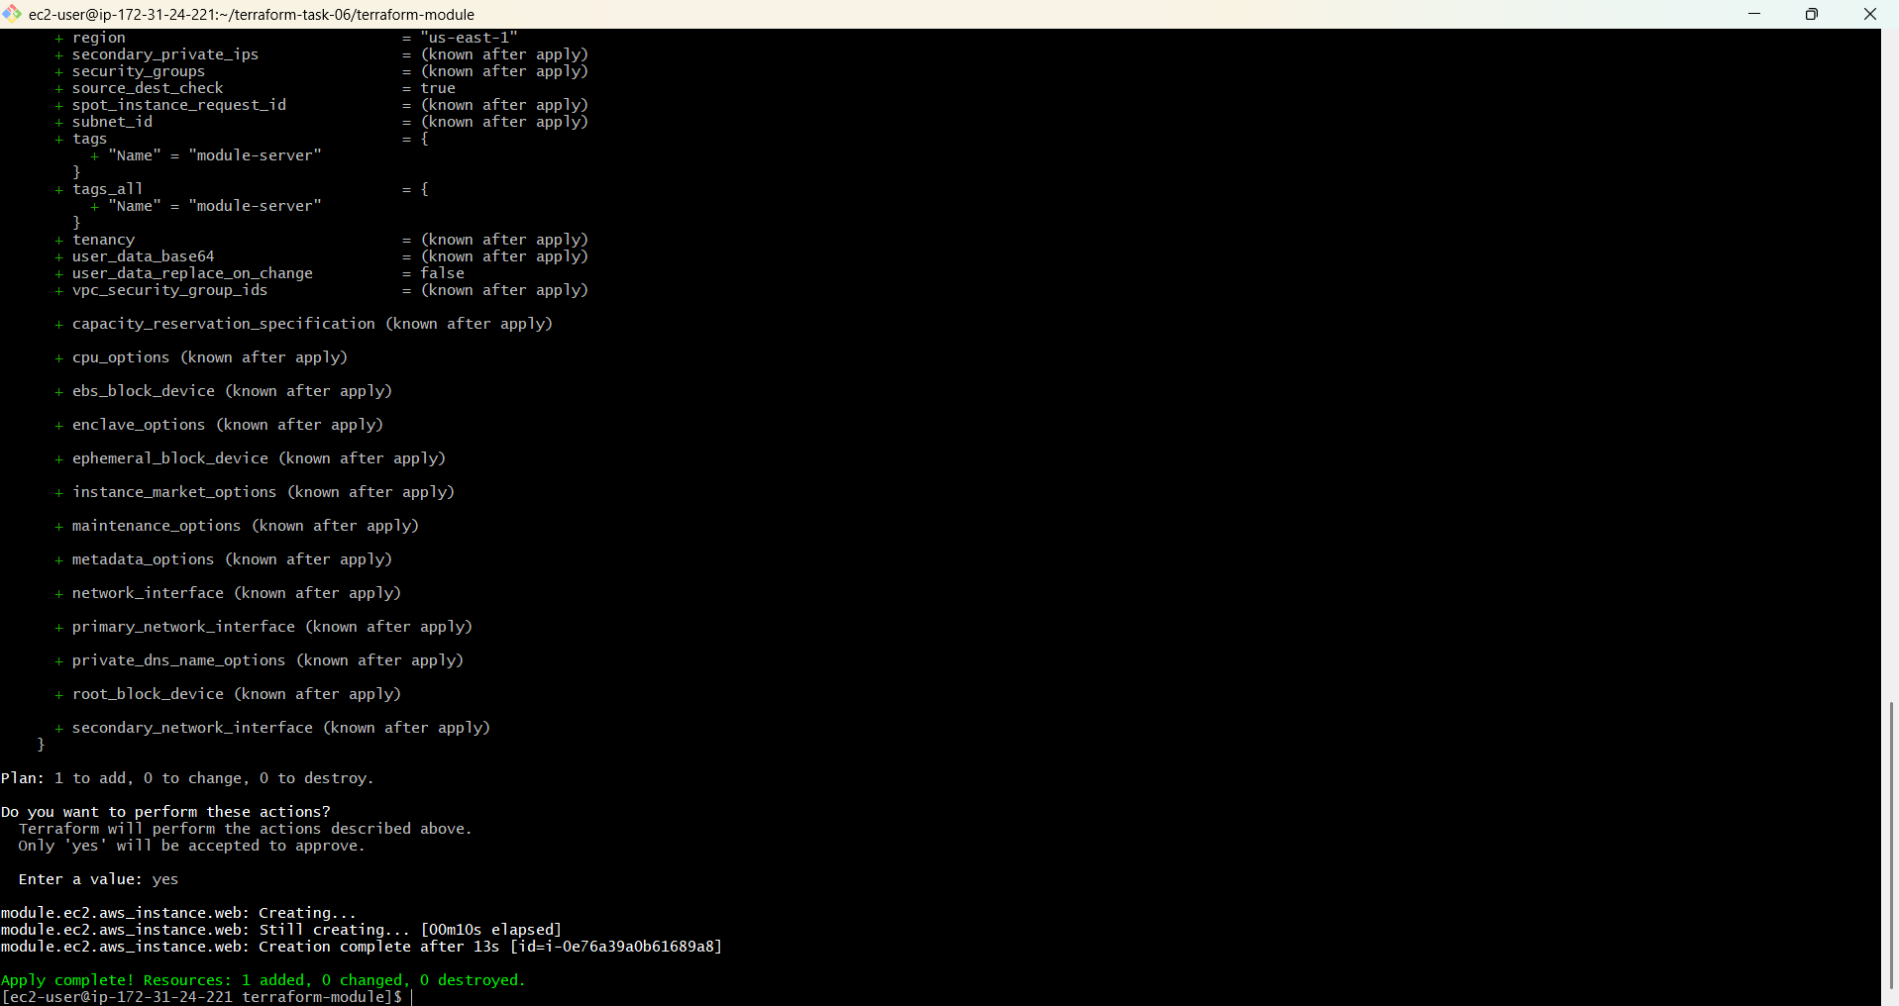terraform state list

3). Provision EC2, S3, and VPC using Terraform modules.
Step 1: Create folder structure
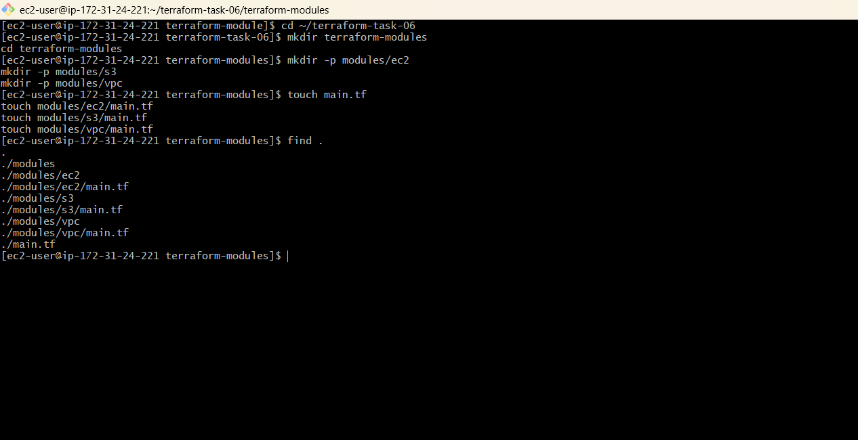

Step 2: Create EC2 module
Open:
modules/ec2/main.tf

Add:
resource "aws_instance" "ec2" {
ami = "ami-0354c98ae10b02961"
instance_type = "t2.micro"
key_name = "krishna7"

tags = {
Name = "module-ec2"
}
}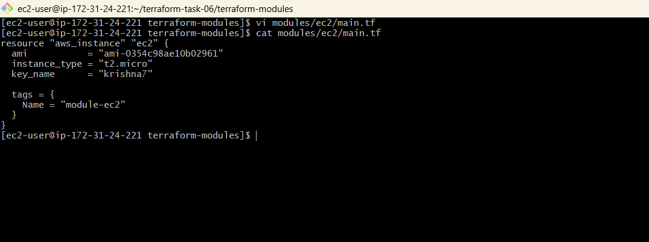
This module creates one EC2 instance.

Step 3: Create S3 module
Open:
modules/s3/main.tf 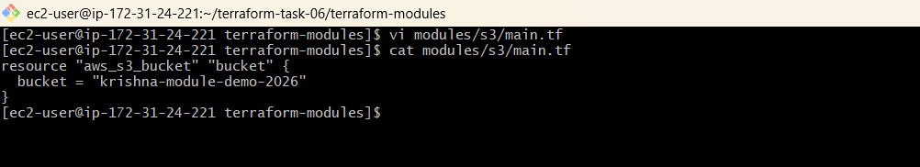
Add:
resource "aws_s3_bucket" "bucket" {
bucket = "krishna-module-demo-2026"
}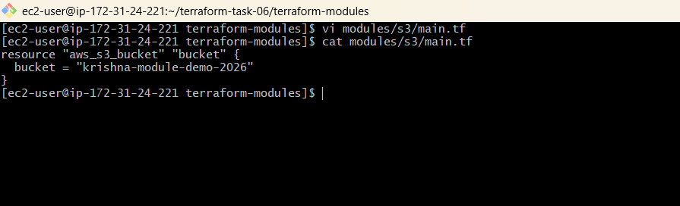
This module creates an S3 bucket.
S3 bucket names are globally unique. If this name already exists, change it.

Step 4: Create VPC module
Open:
modules/vpc/main.tf 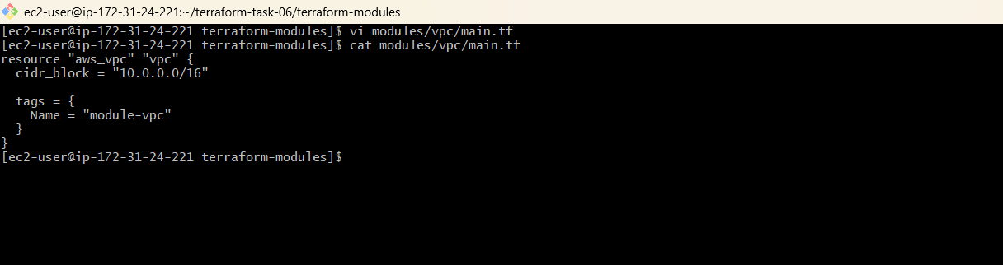
Add:
resource "aws_vpc" "vpc" {
cidr_block = "10.0.0.0/16"

tags = {
Name = "module-vpc"
}
}
This module creates a VPC.

Step 5: Call the modules
Now open the root:
main.tf
Add:
provider "aws" {
region = "us-east-1"
}

module "ec2" {
source = "./modules/ec2"
}

module "s3" {
source = "./modules/s3"
}

module "vpc" {
source = "./modules/vpc"
}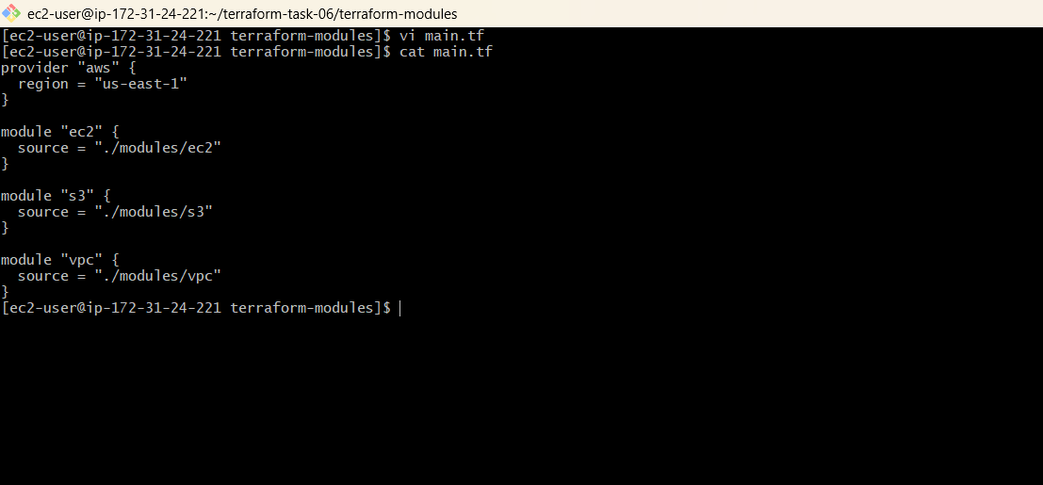

Step 6: Initialize Terraform
From the terraform-modules folder:
terraform init 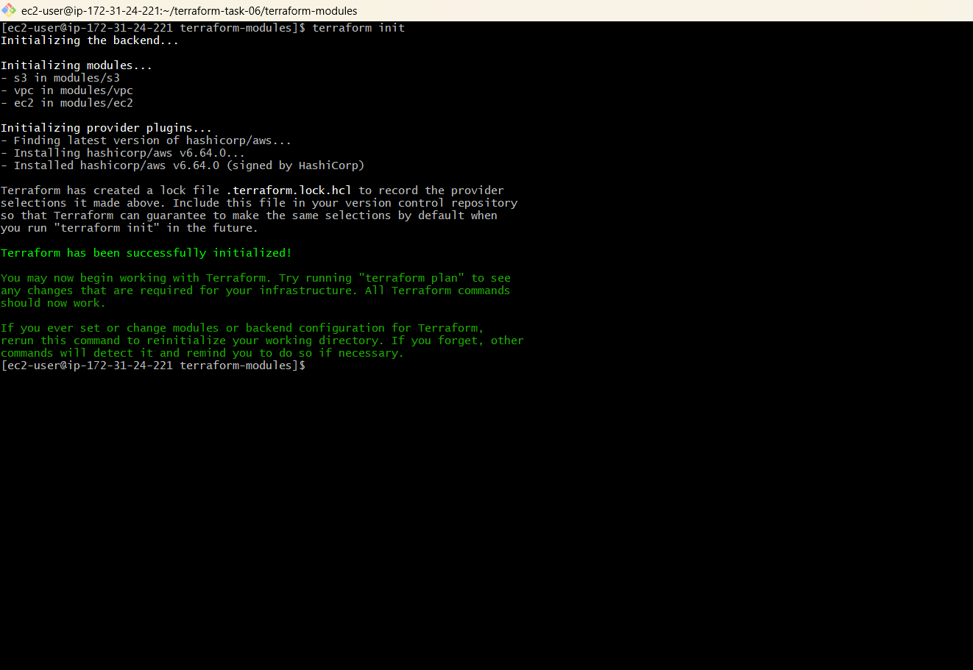
Terraform has been successfully initialized!

Step 7: Validate
terraform validate
Expected: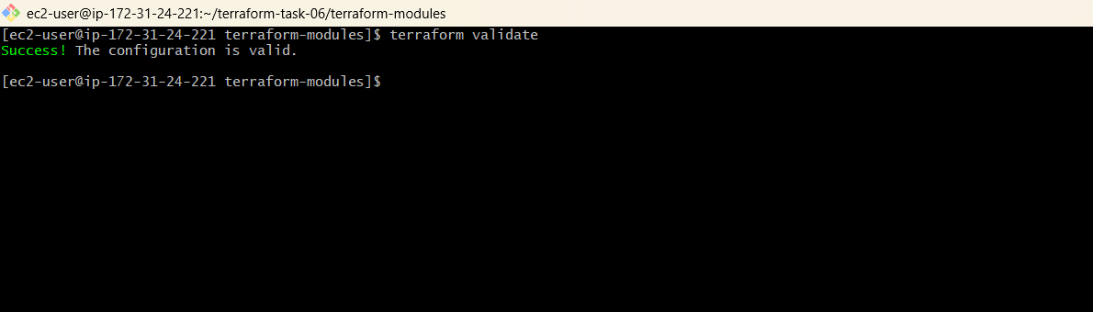
Success! The configuration is valid.

Step 8: Plan
terraform plan
Terraform should show resources for:
EC2
S3
VPC
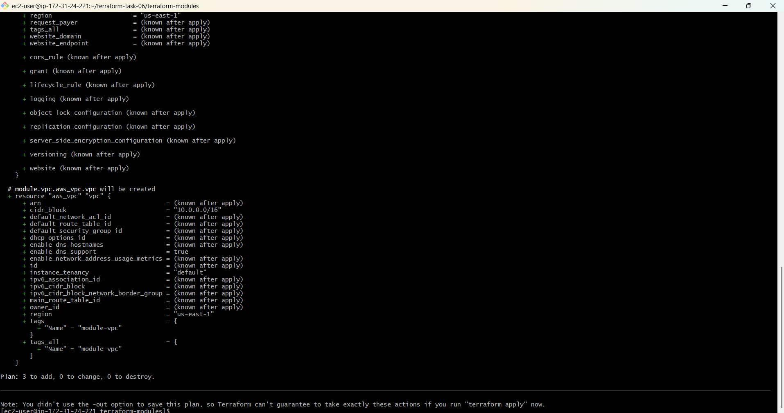

Step 9: Apply
terraform apply
Enter:
yes 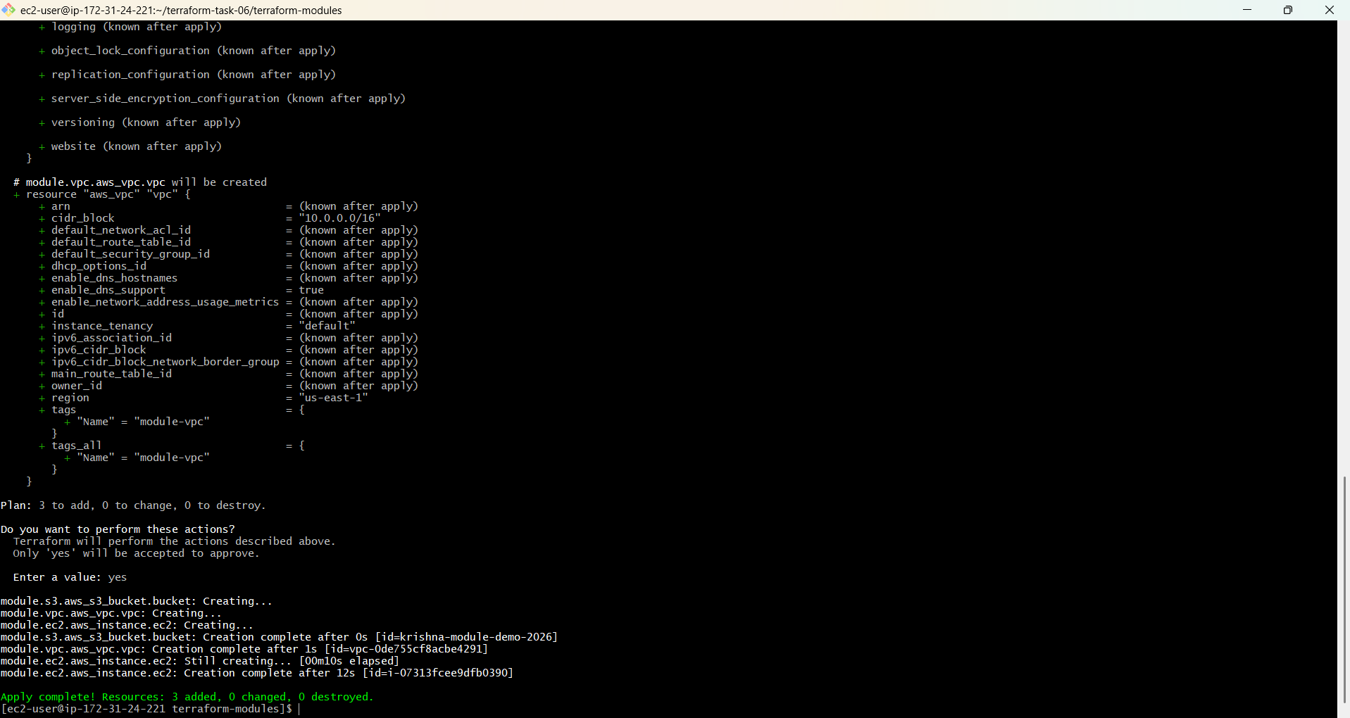

Terraform will create:
EC2
S3 Bucket
VPC

Step 10: Verify
Run:
terraform state list
You should see:
module.ec2.aws_instance.ec2
module.s3.aws_s3_bucket.bucket
module.vpc.aws_vpc.vpc 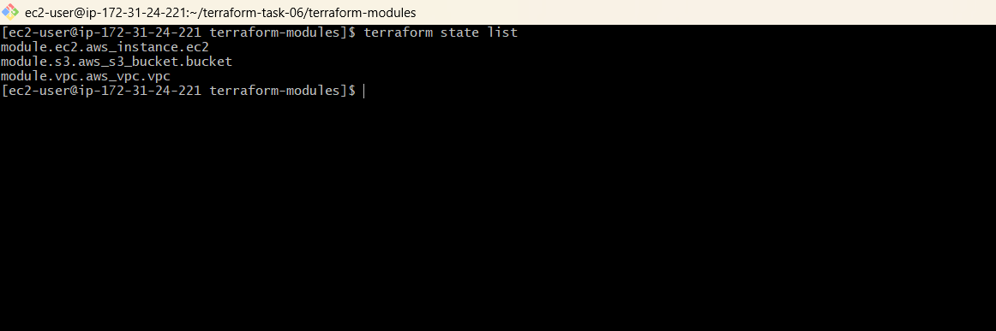
Simple flow to remember for exam
main.tf
↓
calls modules
↓
EC2 module → creates EC2
S3 module → creates S3
VPC module → creates VPC
Definition for interview/exam:
A Terraform module is a reusable collection of Terraform configuration files used to organize and reuse infrastructure code.

4). Provision EC2 for 3 different environments (Dev, Staging, and Prod) using Terraform workspaces.
1. Create folder
mkdir terraform-workspace
cd terraform-workspaceCreate: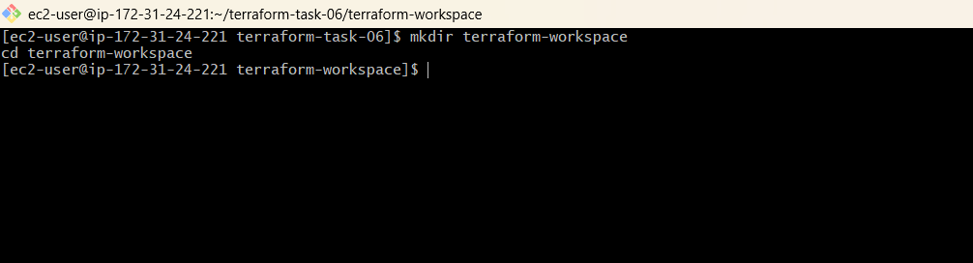
terraform-workspace
└── main.tf
2. Add main.tf
provider "aws" {
region = "us-east-1"
}

locals {
instance_type = {
dev = "t2.micro"
staging = "t2.small"
prod = "t2.medium"
}
}

resource "aws_instance" "web" {
ami = "ami-0354c98ae10b02961"
instance_type = local.instance_type[terraform.workspace]
key_name = "krishna7"

tags = {
Name = "${terraform.workspace}-server"
}
}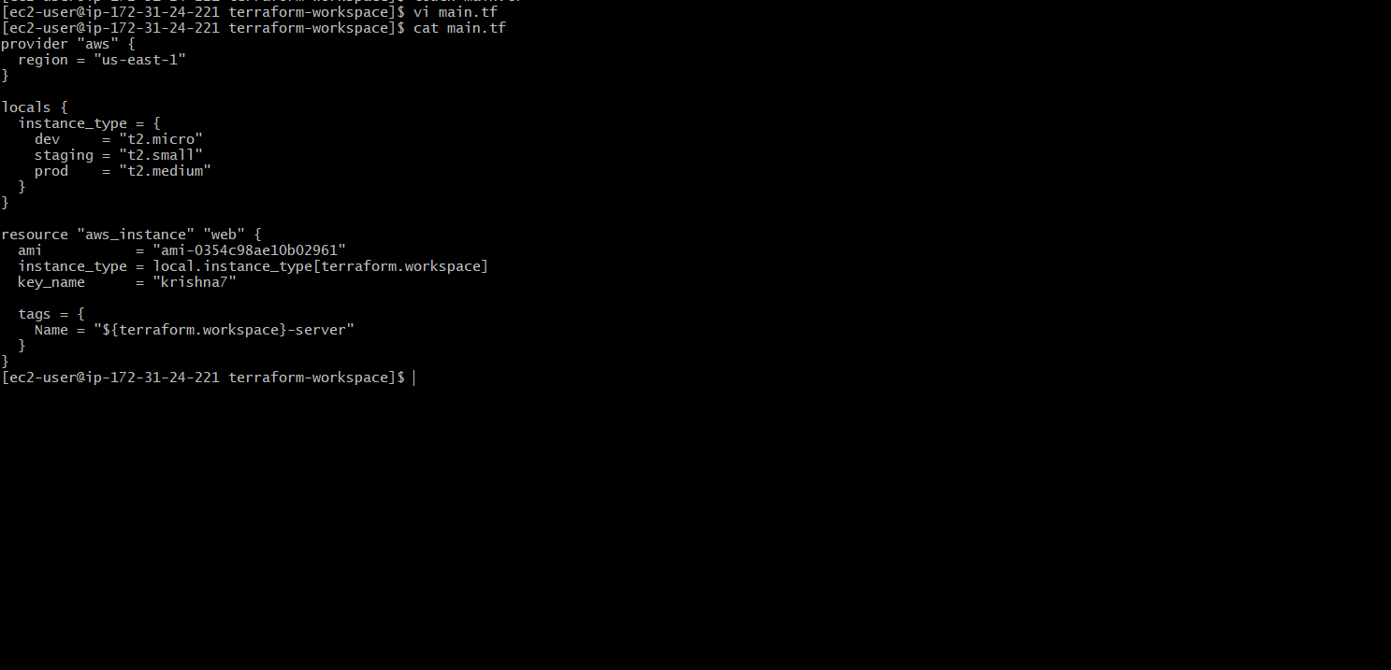

3. Initialize
cd C:\Users\padma\Desktop\terraform-task-06\terraform-workspace
terraform init 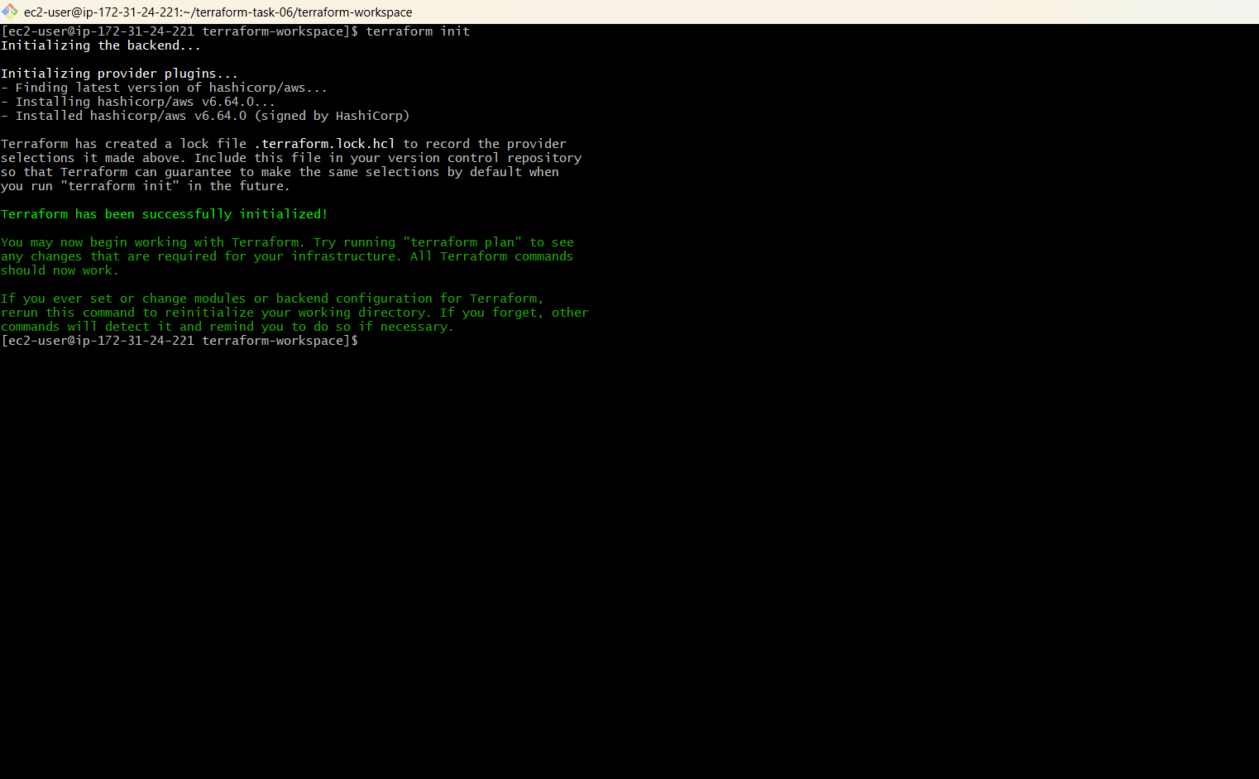
terraform validate
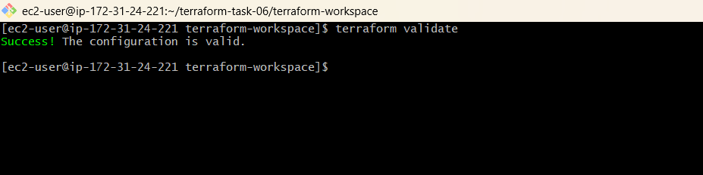
4. Dev
terraform workspace new dev
terraform workspace show
terraform plan
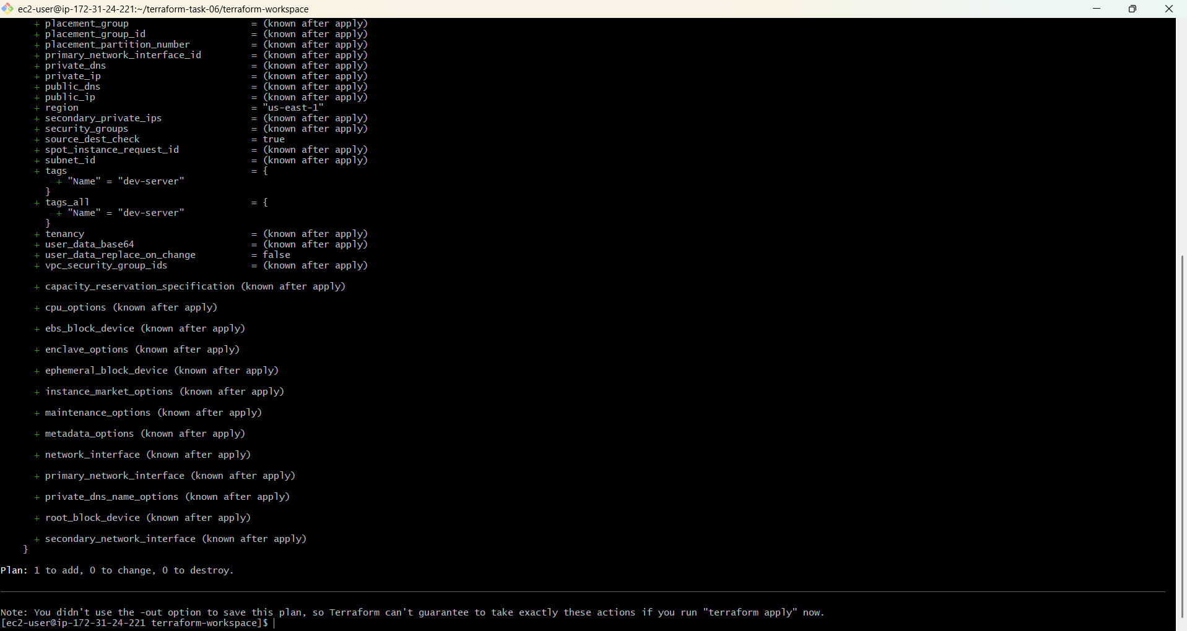
terraform apply

Enter:
yes 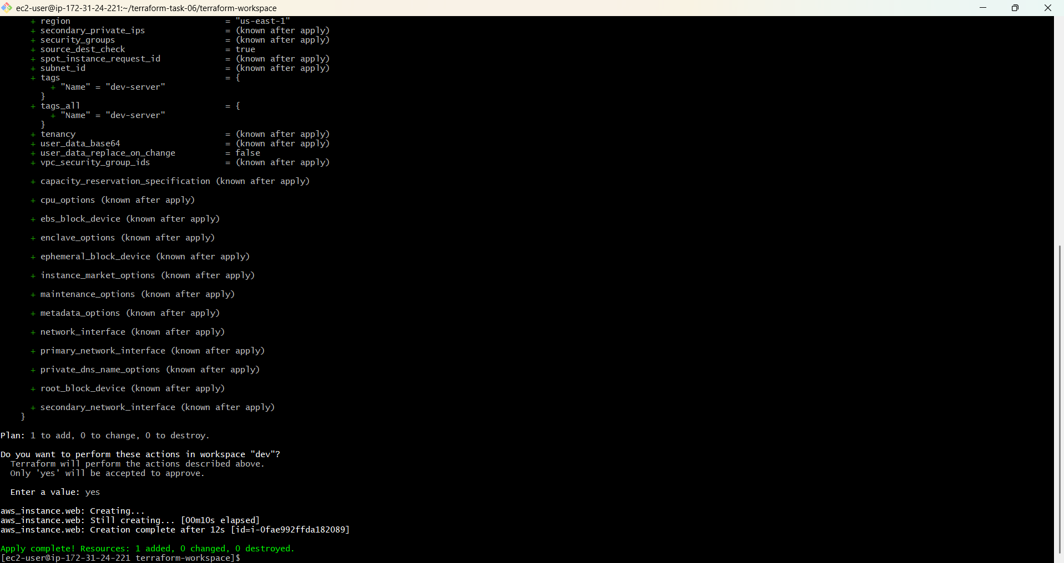
Creates:
dev-server
5. Staging
terraform workspace new staging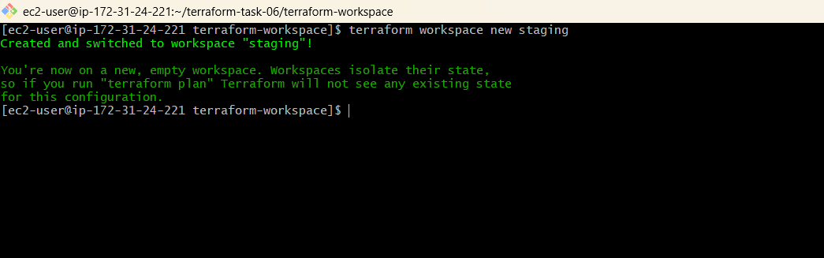
terraform workspace show 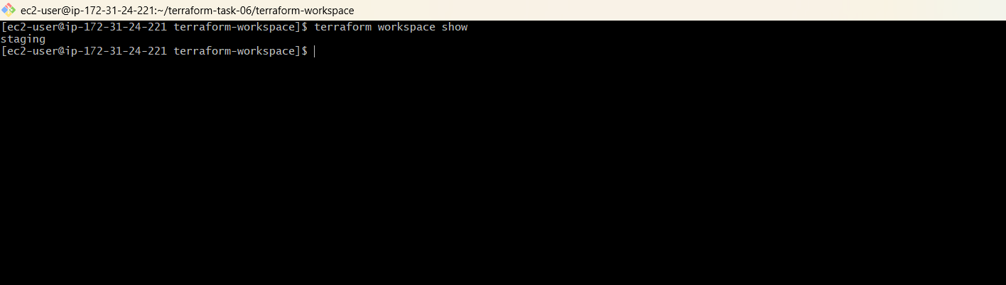
terraform plan 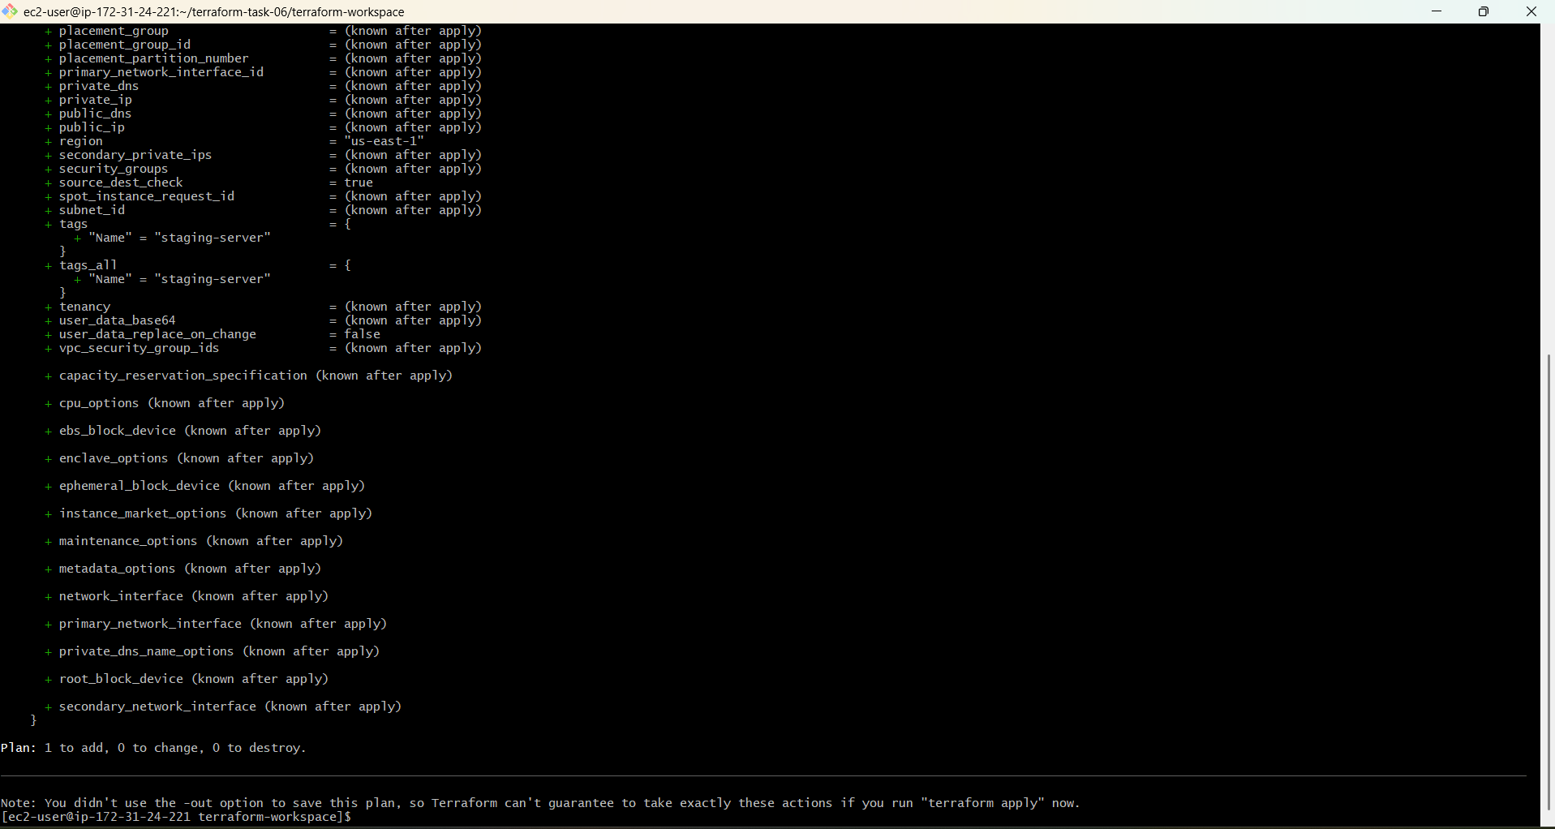
terraform apply 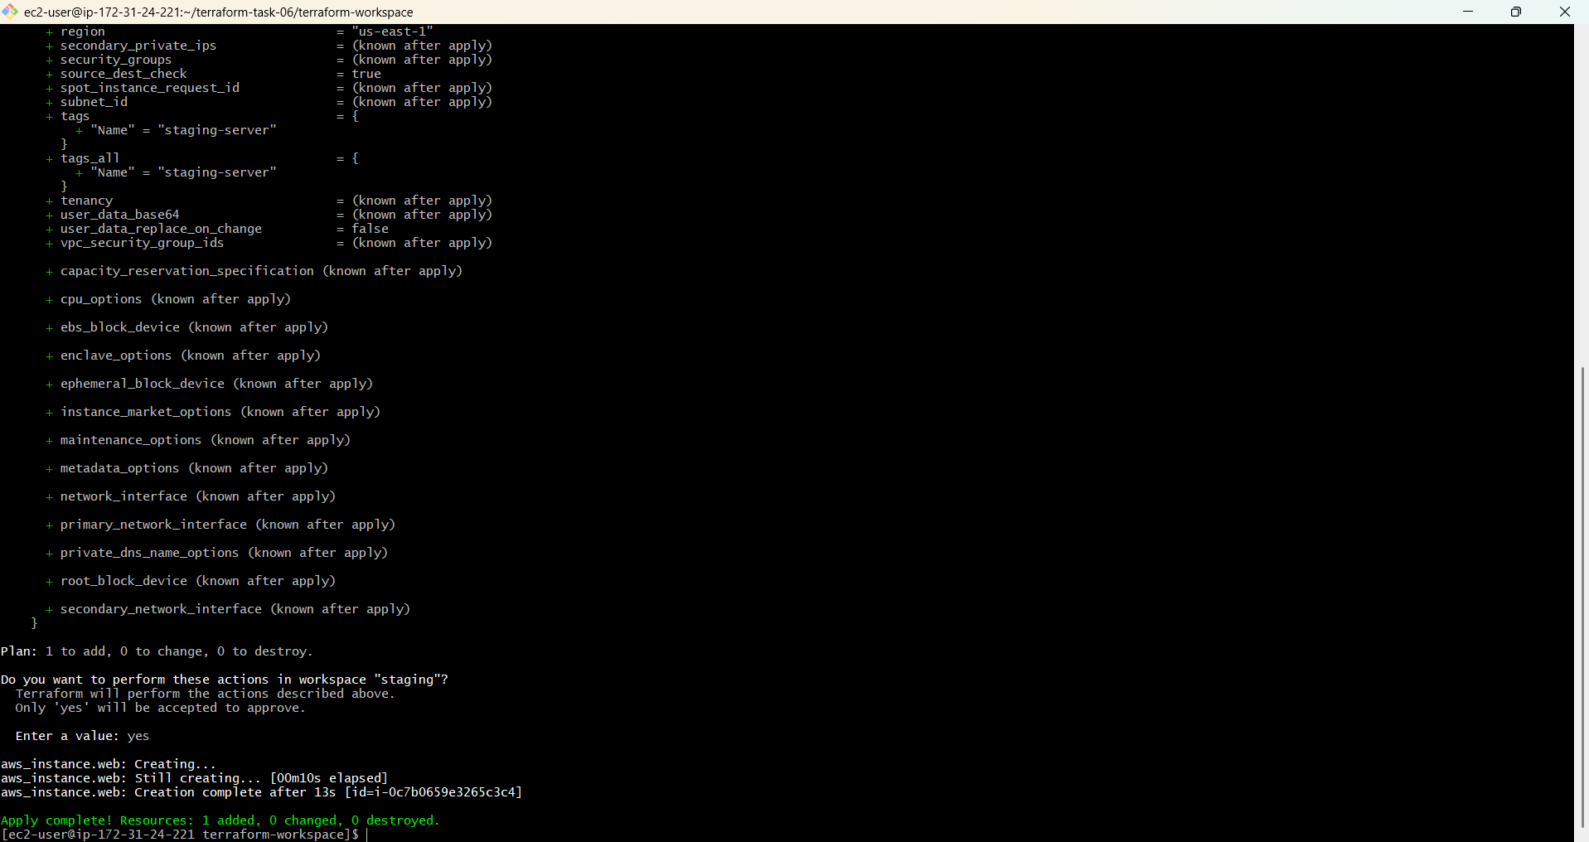
Creates:
staging-server
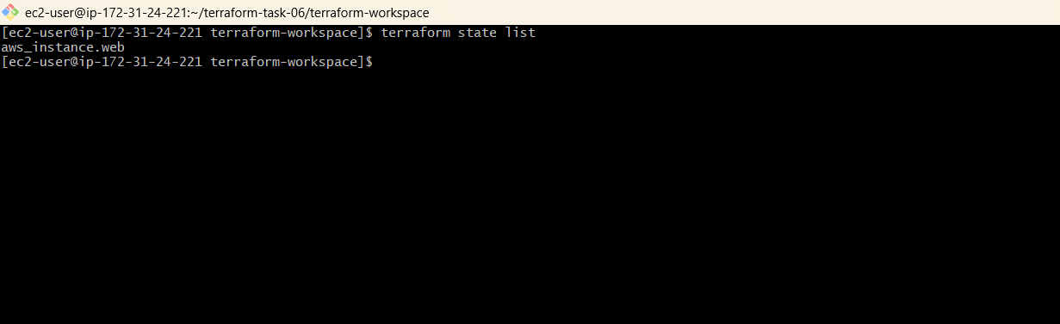
6. Prod
terraform workspace new prod 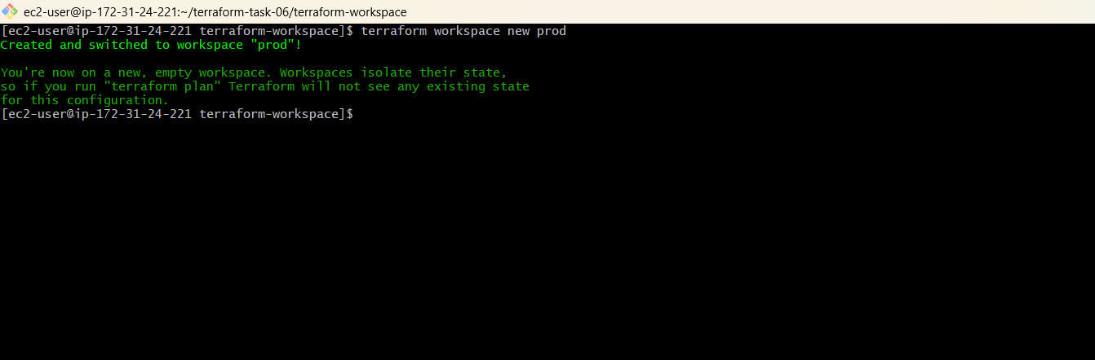
terraform workspace show 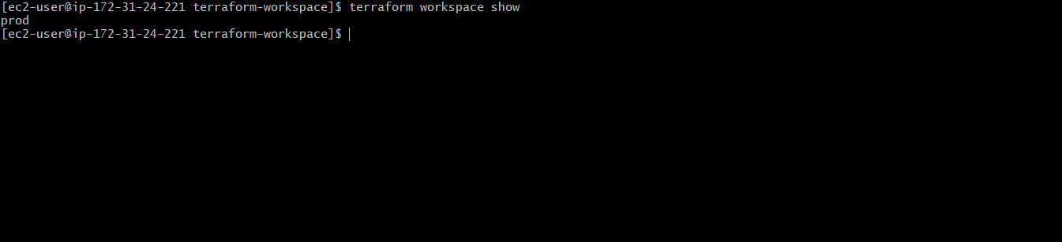
terraform plan
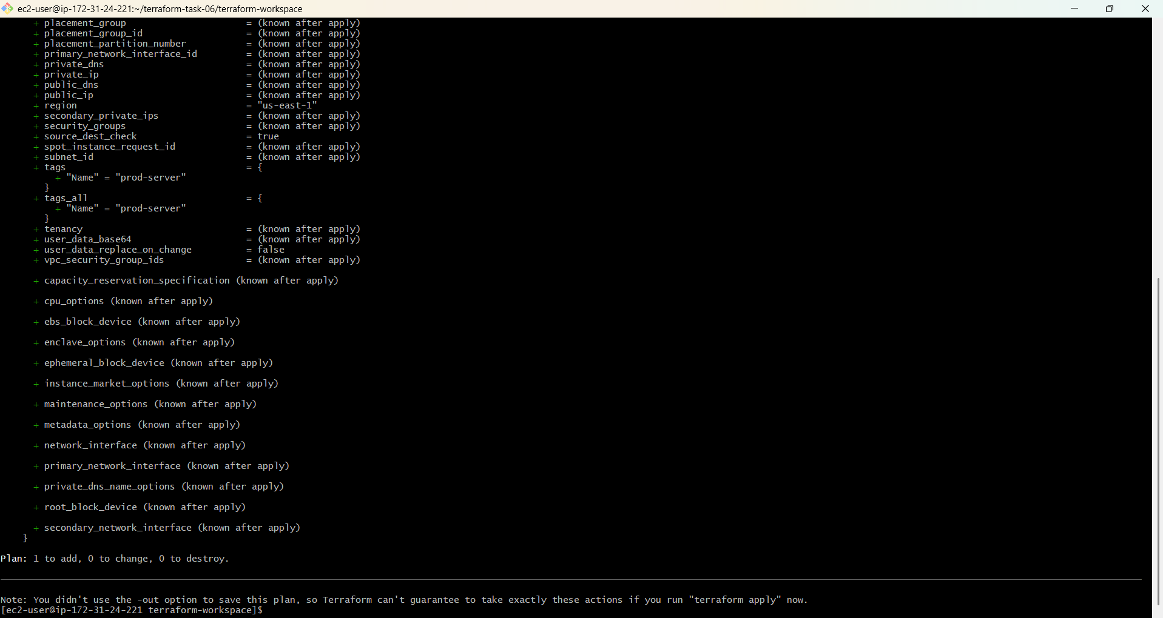
terraform apply 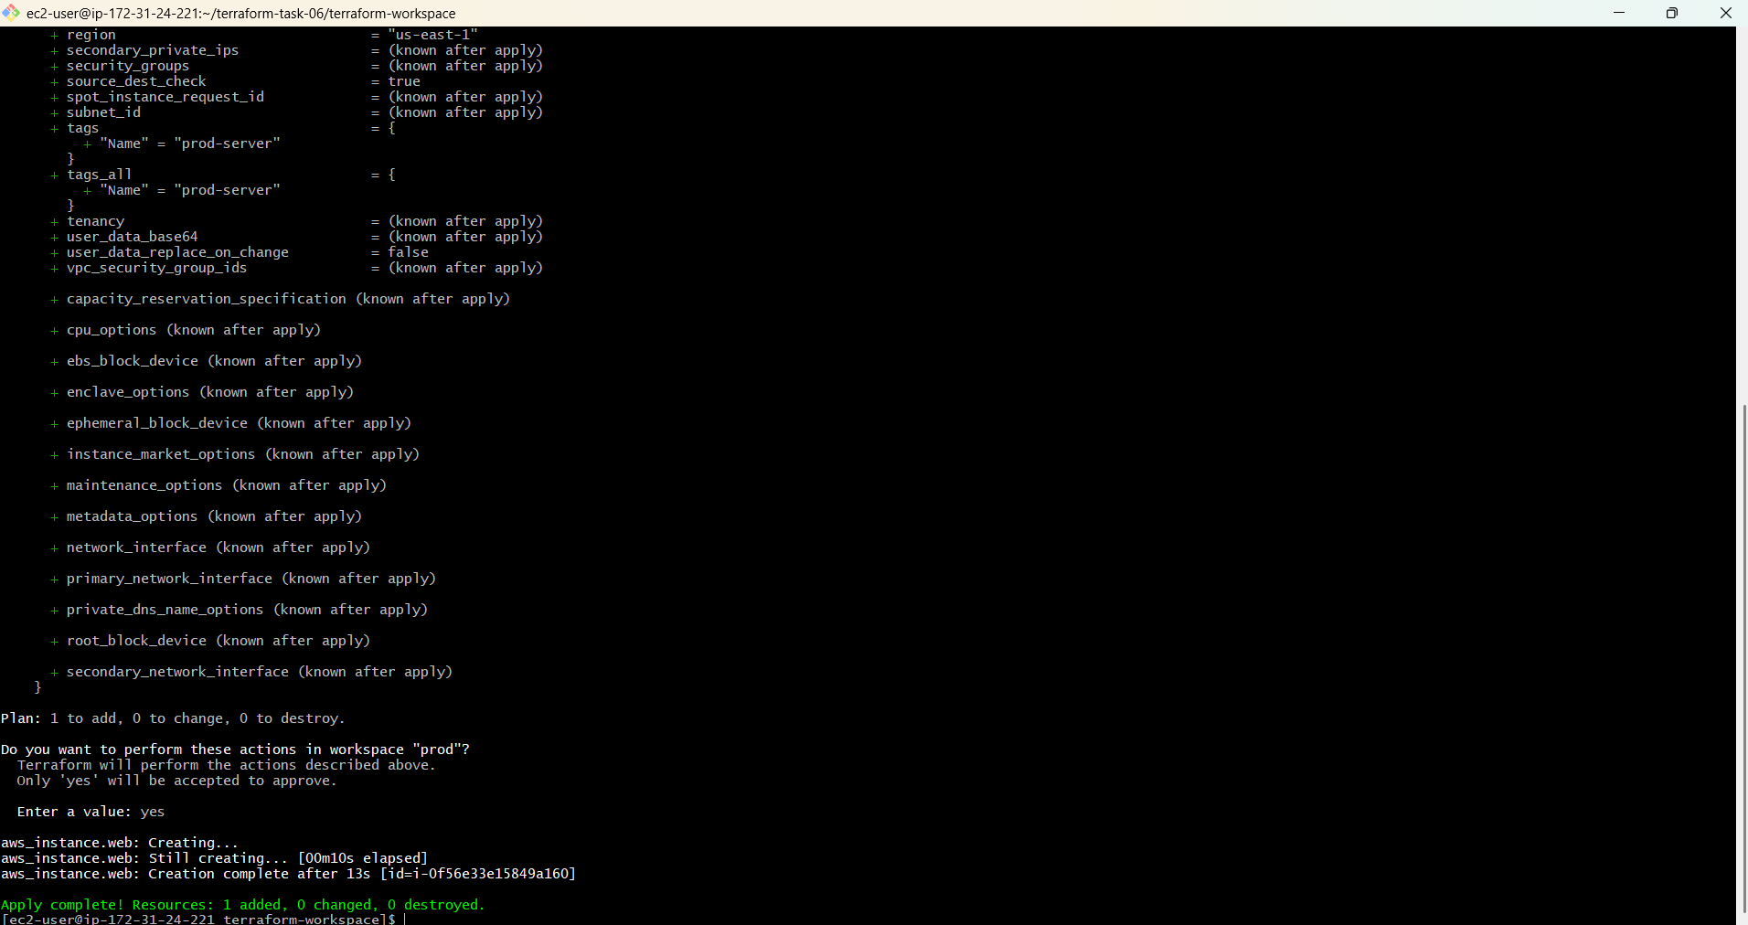
Creates:
prod-server
7. Verify workspaces
terraform workspace list
Expected:
default
dev
staging
* prod
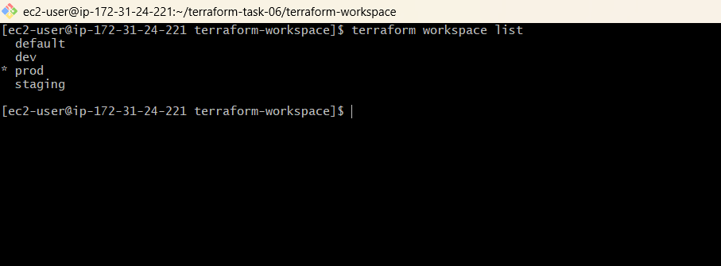
8. Verify AWS
EC2 should show:
dev-server
staging-server
prod-server 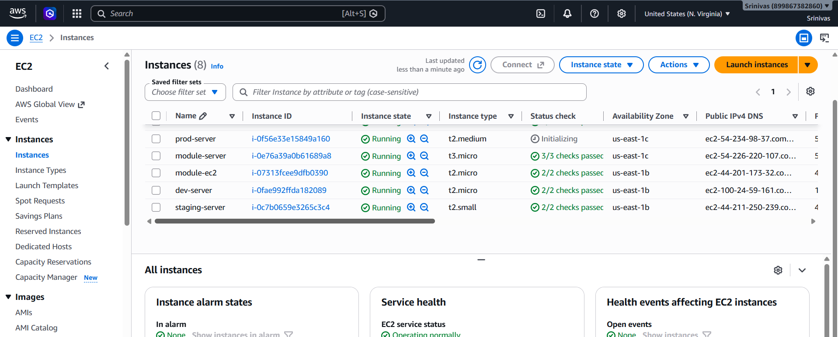
Key point: Same main.tf + separate workspaces = separate environment states.

